AS91892 - Visual Diary
Use advanced techniques to develop a database (4 Credits)
1. Title of Project: Biltong Bites Database

2. Purpose of Project: To create a database to help with the ordering of a business named Biltong Bites. It will includes a table for: 1) Orders. 2) Stock. 3) Customers. 4) Staff. 5)

3. Select at LEAST TWO Advanced Techniques Used in This Database Design
Advanced Techniques | Write Yes if Used in This Database Design
Linking data in related tables or nodes using queries or keys
Writing custom queries to filter and/or sort data
Using logical, mathematical and/or wildcard operators
Customising presentation of the data
Using custom forms to add user input to the database
Setting validation rules for data entry.

4. Logo Design for Database

5. Planning and design of the database
Tables:
Stock Table
Staff Table
Customers Table
Orders Table
Order Items Table

5.1 Structure of Database (This includes ER Diagram & Data Dictionaries)
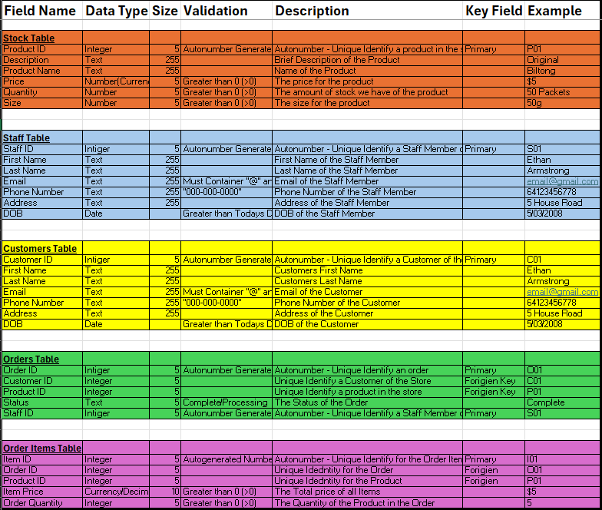
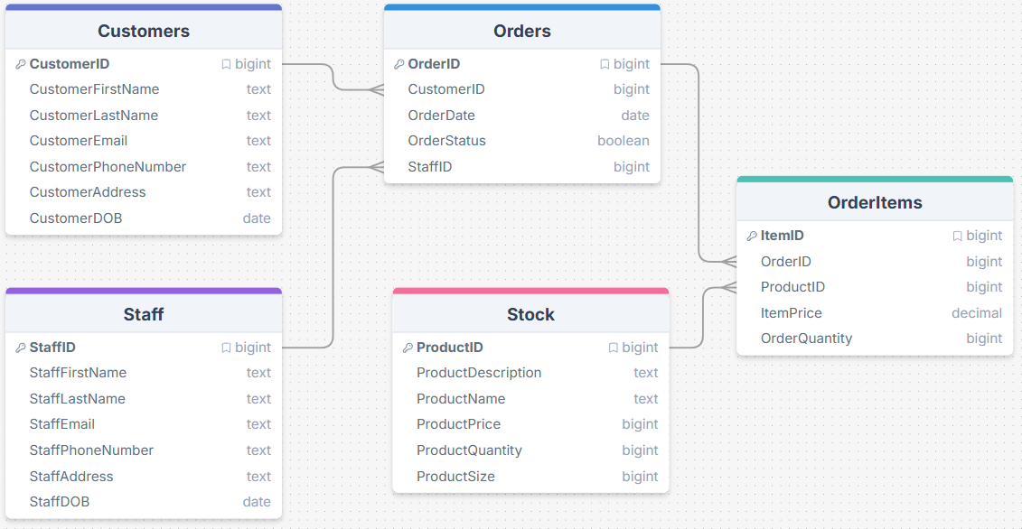
5.2 Design of Database (This includes screenshots and explanations of tables, data types, validation checks, relationships)
5.3 Queries (This includes screenshots of SQL Filter Queries, Sorting Queries, Wildcard Operator Queries)

6. Forms (Screenshots of Forms including Login Form, Form Buttons, Styling Form, Adding Logo in Form, etc.)

7. Relevant Implications (Choose at least TWO)
(For Achievement - explaining relevant implications.)
(For Merit - addressing relevant implications.)
- Social
- Cultural
- Legal
- Ethical
- Intellectual property
- Privacy
- Accessibility
- Usability
- Functionality
- Aesthetics
- Sustainability and future proofing
- End-user considerations
- Health and safety
Relevant Implication | Explain Relevant Implication | Address Relevant Implication (Merit)

8. Testing
(This includes testing for validation with valid, invalid and boundary data, showing all queries work as intended, all form controls work as intended, a screen recording showing comprehensive testing of entire database)
Comprehensive testing along with video evidence with voiceover or captions is needed for Merit & Excellence. A sample table is shown below. Modify this table for your project and keep on adding rows for testing.
For Merit, evidence of how the outcome was improved using testing procedures is required.
Test No. | What Was Tested | Test Input/ Action | Expected Result | Actual Result | Pass/ Fail | Notes/ Improvement
1 | Data entry form | Enter Valid Name | Record is Entered Correctly | Record is Entered Correctly | Pass | Name entered correctly
2 | Data entry form | Enter Numbers in Name Field | Error Message Should Appear | Error Message Should Appear | Pass | Invalid Data Rejected
3 | Data entry form | Enter Alphabets in Age Field | Error Message Should Appear | No Error Message | Fail | Validation Check is Applied to Accept only Numbers. (Show the screenshot of validation applied)
4 | Query | Query to Display All Students Names Who Are Absent in Year 9 | Names of Year 9 Students Who Are Absent | Names of Year 9 Students Who are Absent and Present | Fail | Modify Query to show only absent students. (Show the screenshot of query applied)
5 | Query | Query to Display All Year 12 Students Names in Ascending Order | Names of Year 12 Students in Ascending Order | Names of Year 12 Students in Ascending Order | Pass | Names are displayed in Ascending Order
6 | Relationship | Enter Data in Loan Table about a Device Lend to a Student Who Does Not Exist in Student Table | Error for non-existing record in student table | Error for non-existing record in student table | Pass | Relationship between Load and Student Table is Working Correctly
7 | Data Entry Form | Click Delete Button | Delete the selected record | Did not delete the selected record | Fail

9. User Testing (Volunteer) – (For Merit)
(The student has asked a volunteer to test the database and has made improvements/changes based on this testing.)
Test No. | What Was Tested | Test Input/ Action | Expected Result | Actual Result | Pass/ Fail | Notes/ Improvement

10. Iterative Improvements – (For Excellence)
(Make sure to record iterative improvement in the below table as well as video evidence.)
For Excellence, iterative improvements is required throughout the design, development and testing process.
Improvement Number | Area Improved | Change Made | Why the Change was Needed | Result After Improvement
1 | Login system flexibility | Modified SQL so admin can create additional user accounts | Allows the system to support more users in future | Admin can now create multiple login accounts
2

11. Presenting Data Effectively for the Purpose and End Users (For Excellence)
(You should explain how the database presents information clearly and usefully for the users. You may show how queries, forms, sorting, and field organisation help users easily enter data and retrieve the information they need.)

